Common Data

Author: | Catalin Gyorgy
Revision: | 1.0
File: | CommonDataS1.docm

History

Revision | Date | Author, Editor | Reason
1.0 | 27.04.2022 | Catalin Gyorgy | Initial release

Table of Contents
1 History 2
2 Table of Contents 3
3 Overview 4
3.1 Module Description 4
3.2 Input-Output 4
3.3 Module Interdependencies 4
3.4 Resource Usage 4
4 Export Interface 5
4.1 Static View 5
4.1.1 Functions 5
5 Internal Design 6
5.1 Static View 6
6 Add new CommonData parameters 7
6.1 Common data should be added in CommonData_enIDs enum in CommonDataE.h file 7
6.2 Create a new variable in CommonDataI.h that is of the type of variable needed to be shared with the system 7

Overview

Module Description

CommonData is responsible for sharing data between modules of the system.

Input-Output

Node Table
Node | Description
EEPROM parameters | N/A
Common data parameters | N/A
Indications | N/A

Module Interdependencies

CommonData module is linked to all the other modules that has to share data or has to retrieve data.

Resource Usage

Function Runtimes
Function  (measured without Scheduler-calls) | runtime  [μsec] | Frequency  [calls / sec]
CommonData_Setup | on event | init
CommonData_ReadQueues | 10 | 100

Export Interface

Static View

Functions
Function Description
Prototype: | void CommonData_Get(CommonData_enIDs ID, void *const pvBuffer)
Documentation: | This function is used to get the values of the data in CommonData
Parameters: | CommonData_enIDs ID: the ID of the common data  void *const pvBuffer: the pointer where the data will be copied
Return Values: | void

Function Description
Prototype: | void CommonData_Set(CommonData_enIDs ID, void *const pvBuffer)
Documentation: | This function is used to set values data of CommonData
Parameters: | CommonData_enIDs ID: the ID of the common data  void *const pvBuffer: the pointer from where the data will be copied
Return Values: | void

Function Description
Prototype: | void CommonData_ReadQueues()
Documentation: | This function is the cyclic function of the CommonData moude and it is used to get the data from queues and copy it to the local variables of the module
Parameters: | N/A
Return Values: | void

Function Description
Prototype: | void CommonData_Setup()
Documentation: | This function is used to initialize the queues and set the pointers for every CommonData variables
Parameters: | N/A
Return Values: | void

Internal Design

Static View

Functions
Function Description
Prototype: | void CommonData__Events_X(CommonData_enIDs ID) – where X is the name of the data
Documentation: | These functions are called when data value is changed. This function will call functions from other modules to notify when there is a change on the CommonData element
Parameters: | CommonData_enIDs ID: the ID of the common data
Return Values: | Return values / void

Add new CommonData parameters
This chapter describes the steps to follow when a new CommonData parameter is needed.

Common data should be added in CommonData_enIDs enum in CommonDataE.h file

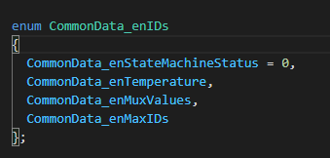

Make sure that the enum member CommonData_enMaxIDs is kept as the last member.

Create a new variable in CommonDataI.h that is of the type of variable needed to be shared with the system

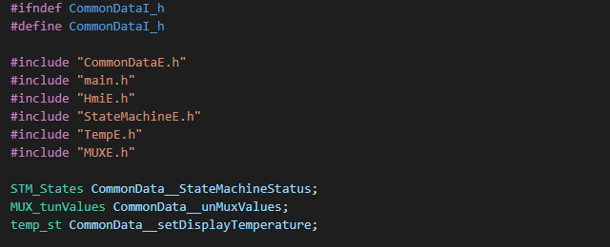

Update the initialization of the const variable CommonData__Sizes in CommonDataI.h, with the size of the new added parameter type.
Make sure that the place of the new added element in array matches the place where the name of the new data was added in Chapter 6.1

Declare a function CommonData__Events_X in CommonDataI.h, where X is the name of the CommonData variable.
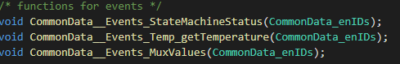
For example:
If we add the variable CommonData_enTemperature, the new declared function will be CommonData__Events_Temperature.

Add the pointer to the function to the initialization of CommonData__Events in CommonDataI.h

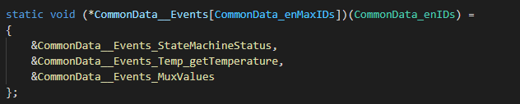

Make sure that the place of the new added element in array matches the place where the name of the new data was added in Chapter 6.1

In the function CommonData_Setup in CommonData.cpp, assign the value of the pointer to the variable added at Chapter 6.2, in the array CommonData__Addresses at the position described at Chapter 6.1.
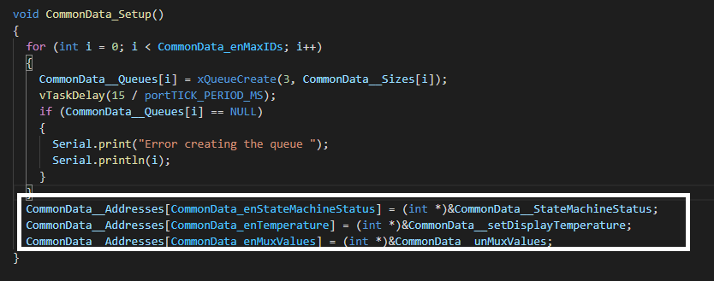

In CommonData.cpp, define the function declared in Chapter 6.4.

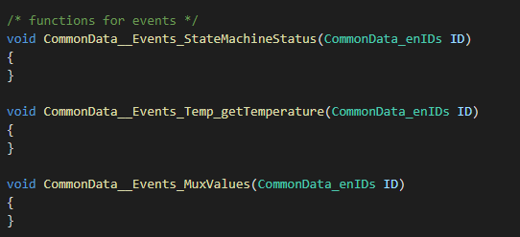

These functions can be used to call functions from other modules, for notifications when the data is changed.

